|  |  |  |
| --- | --- | --- |
| **Write an application in C++ using appropriate exceptions. Perform the given operations.** | | |
| **Requirement Tag** | **Requirement Description** | **Comments** |
| EXC/01 | Read and fill a string array with atleast 2 inputs from command line.   Incase of incorrect number of arguments(less), throw an exception with error message as "Insufficient arguments. Enter atleast 2 or more strings", catch and handle this exception. | Hint: Use throw(<msg>) to raise an exception with string message |
| EXC/02 | Prompt, read an index, fetch the string at given index from string array. If index is invalid raise an overflow or underflow error |  |

**EXE/01**

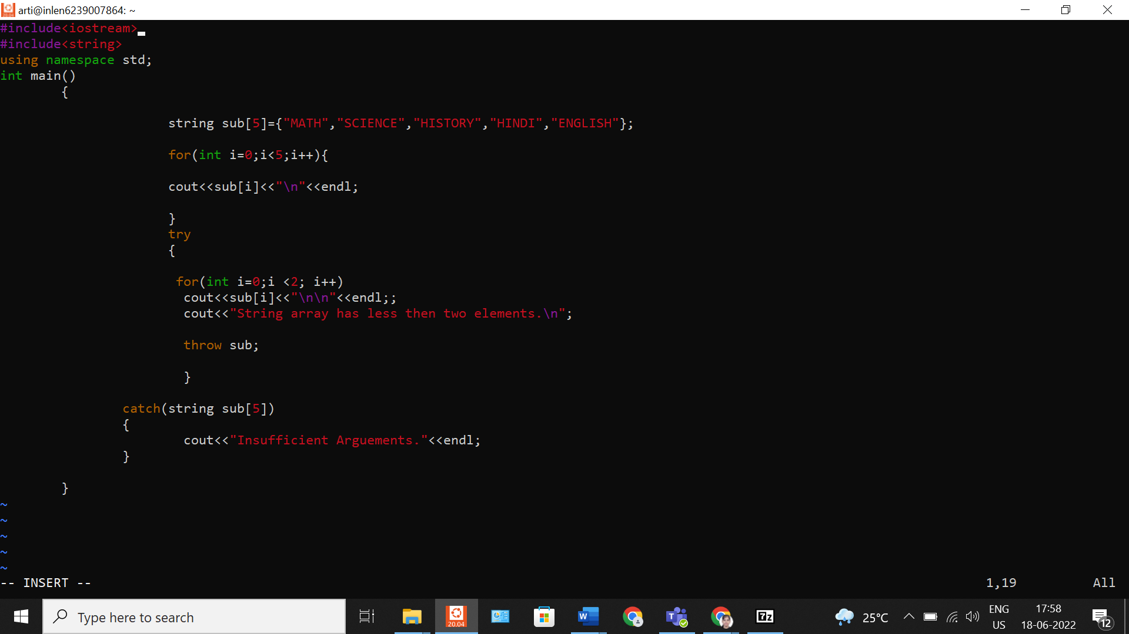

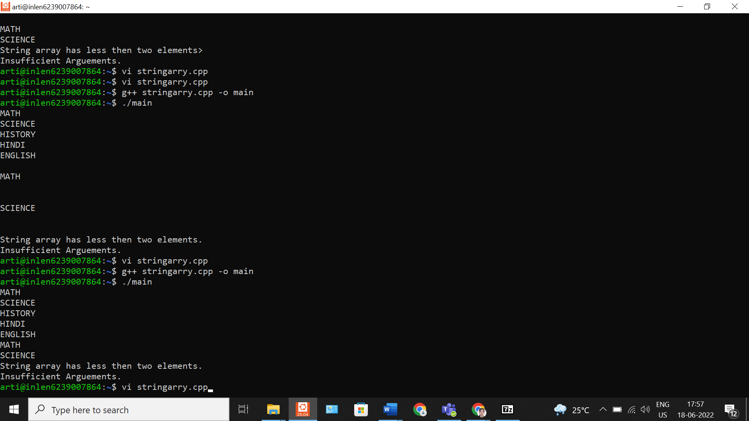

#include <iostream>

using namespace std;

int main() {

string a[5]={"hi","Hello","How","are","You"};

try{

for(int i=0;i<4;i++)

if(i<1)

{

cout<<a[i]<<"\n" ;

//cout<<"Array has sufficient arguments"<<"\n";

}

else

throw i;

}

catch(int i)

{

cout<<"Insufficient Arguments "<<i<<endl;

}

return 0;

}